Name_________________________________________
125 points possible (10 of which are for identifying where answers came from)

Rename the file to include your name (e.g. capaultmidterm). Open book, open notes (including our website and the links on it – no Google/Bing searches). NOTE: It is NOT permissible to use a midterm exam for notes from someone you know who took this course previously. Discuss your answers with no one until after the due date. You are on the honor system with regards to these items. You agreed to a code of ethics document as part of your acceptance into this department. Honor it!
IMPORTANT NOTE 1: For each problem, describe where your answer came from (self, book, notes, web address). Failure to do so will result in a loss of 10 points.

IMPORTANT NOTE2: NO LATE EXAMS WILL BE ACCEPTED FOR POINTS. CANVAS WILL DISABLE TURN-IN. YOU HAVE MULTIPLE DAYS TO COMPLETE THE EXAM – THERE ARE NO EXCUSES FOR A LATE EXAM.

For most questions you may use words, class diagrams or Java/C# code to illustrate your
answer, unless the question asks for a specific format. When you draw a class diagram, indicate the methods that make the pattern work. Also specify the type of relation (inheritance / composition) between classes and type of class (interface / abstract class / regular) as indicated in the sample UML class diagram below. You may also use the terms “is-a” or “has-a” to indicate the relationships. For each class & interface in your diagram indicate what it does. Use a circle to describe the responsibilities of each class, as necessary. The more detail you include; the better chance you have at earning full credit.

-----------------------------------------------------------------------------------------------------------------
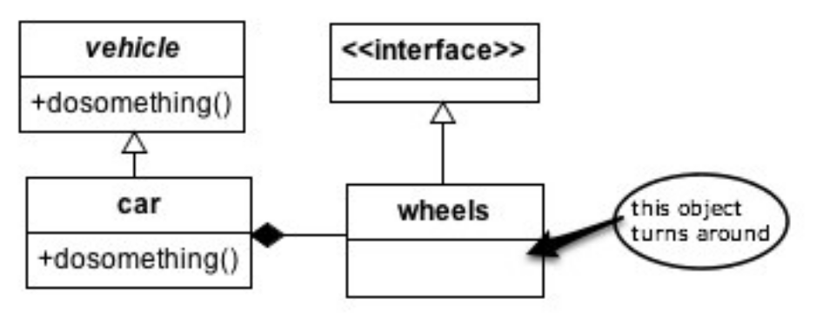
- (8 points) List the four pillars of OO. Give a detailed description of each pillar.
- (6 points) What is a design pattern? What benefits does a pattern provide a community of developers?

- (6 points) Why does inheritance violate encapsulation principles?

- (10 points) (a) Thoroughly describe the following OO principles then (b) list at least one pattern that follows each principle: Single Responsibility, Open/Closed, Liskov Substitution, Interface Segregation, Dependency Inversion (SOLID).

- (15 points) List 5 code smells, describe what each means, and describe how to re-factor each.

- (5 points) Describe coupling. Describe cohesion. Which combination of coupling and cohesion is most desirable?
Design Problems
Three design problems are listed on the pages that follow. Select the most appropriate design pattern to use to address the problem and clearly motivate how it addresses the problem. Furthermore, show an appropriate class diagram followed by enough code fragments to illustrate the implementation of your pattern.

To clarify, you will do three things for each problem. First, list a pattern that you think best solves the problem along with justification for why you chose it/ why it works. Second, draw UML that represents that pattern in the context of the problem. Third, include code fragments/snippets that illustrate application of the pattern.

7. (20 points) You work for a webhosting company that offers a ton of hosting services (Flash Media, MySQL, Subversion) to its customers in addition to a base web hosting
plan. You need to write an application that can easily compute the total monthly service
fees for each plan. Your application must be able to easily support adding new types of
hosting services (such as Ruby on Rails) when they become available.

Sample output could be:
> Basic Hosting, Subversion Hosting, Flash Media Server Hosting, MySQL Hosting(w/3 databases): 59.94 a month.

8. (20 points) You are writing a nifty photo application that can read different photos and then creates thumbnails out of them. Your program supports different image formats (JPG, GIF, PNG etc), which are represented by different reader classes for each format that converts the image to an intermediate decoded image format. You anticipate supporting different types of new images in the near future.

9. (20 points). You have been hired to work for a web-based personal financial management service (like mint.com). Users can get an overview of their financial situation and they can add checking, savings and credit card accounts from different banks that are conveniently compiled into one or more views. Users can access this financial management service either through a desktop application or a mobile device like an iPhone which have different screen sizes and interaction capabilities and hence different views may be required. Bank accounts are checked periodically and whenever a new transaction is detected views must be updated.

10. (5 points) Describe the difference between published and public with regards to interfaces as discussed by Eric Gamma on the link provided on our website. The discussion references Martin Fowler, who formally identified the difference between the two. NOTE: In describing the difference between two items, you must clearly define what each means, then you can clearly and correctly point out the difference(s).

EXTRA CREDIT: Read the slides on the penguin class website titled “Brendan Cassida Talk Notes” then answer the following questions. (a – 2 points) What is a non-functional requirement? (b – 8 points) Choose two patterns and list at least two non-functional requirements that EACH pattern helps with. Justify your choices as necessary.

